**Дата**: 15.05.2025

**Клас**: 5-АБ

**Предмет**: англійська мова

**Тема:** Ігрове шоу: «Навколо світу».

**Мета:** формувати навички вживання лексичних одиниць по темі; удосконалювати навички читання, аудіювання й усного монологічного мовлення; розвивати пізнавальні інтереси учнів; виховувати інтерес до самостійного пошуку потрібної інформації, а також загальну культуру учнів.

**Вчитель**: Руда Д.В.

Хід уроку

1.Greeting

Good afternoon, guys! I’m pickled pink to see you. Are you ready to start our lesson? All set?

2. Повторення

Повторити Irregular verbs .

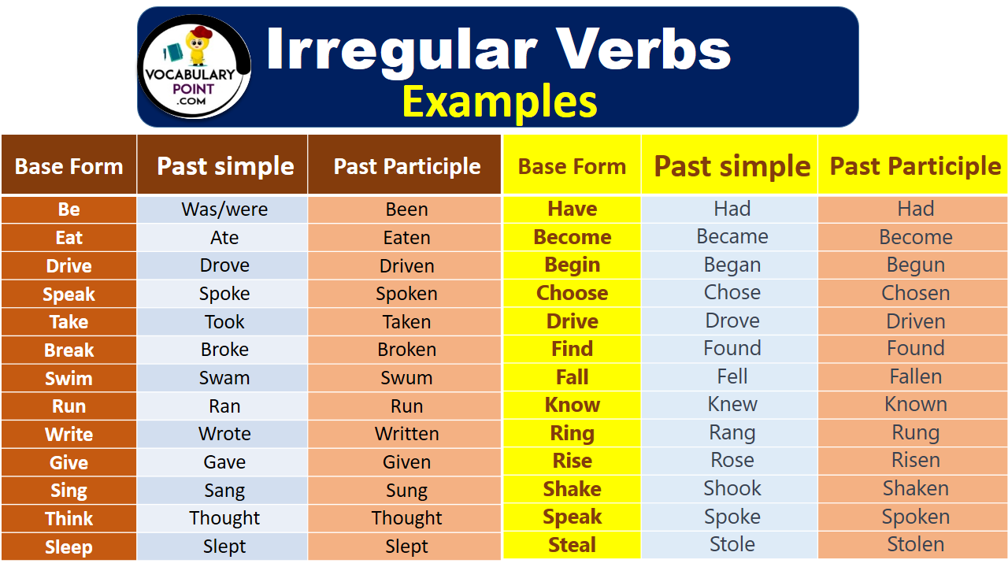

***Вивчити словник (бути готовим до слоникового диктанту) :***

*Careful-обережно (кеафул)*

*Slippery-слизько (сліпері)*

*To put on- одягати (пут он)*

*Overcast: covered with clouds; no sun is visible.- похмуро, сонця нема (овекаст)*

*"Under the weather": feeling ill or in low spirits. (e.g., "I'm feeling a bit under the weather today, so I'll stay home from work.")- мати погане самопочуття ( анде за везе)*

.

*Drizzle-мряка(дрізл)*

*Showers- a [short](https://dictionary.cambridge.org/dictionary/english/short" \o "short) [period](https://dictionary.cambridge.org/dictionary/english/period" \o "period) of [rain](https://dictionary.cambridge.org/dictionary/english/rain" \o "rain) or [snow](https://dictionary.cambridge.org/dictionary/english/snow" \o "snow)*

*Downpour- a lot of [rain](https://dictionary.cambridge.org/dictionary/english/rain" \o "rain) in a [short](https://dictionary.cambridge.org/dictionary/english/short" \o "short) [time](https://dictionary.cambridge.org/dictionary/english/time" \o "time) (дайн пор)*

*Flood-повінь(флад)*

*Hail-град(хейл)*

*Sleet-мокрий сніг(сліт)*

*Snowflake-сніжинка(сноуфлейк)*

*Blizzard-хуртелиця (блізард)*

*Mild: moderate in temperature; neither hot nor cold- помірний, м’який (майлд)*

*"Every cloud has a silver lining": every bad situation has some positive aspect to it. (e.g., "I lost my job, but I found a better one soon after. Every cloud has a silver lining.")- нема лиха без добра( ідіома)*

*To expect-очікувати(експект)*

*To report-повідомити(ріпот)*

*Chilly-прохолодний(чілі)*

*To get cold-холоднішати*

*It`s raining cats and dogs-сильно дощити (ідіома)*

*They cancelled the football game because it was raining cats and dogs.*

3. Wаrm up / Listening

Уважно слухати аудіо трек і дати відповідь на питання вчителя <https://www.youtube.com/watch?v=t9lAjCqxvPQ> .

4. Speaking

Why do you study English?

Do you enjoy speaking in a language that is not your mother tongue?

How well do you speak English?

What level of English would satisfy you? What learning goals do you have? Is it possible to learn to speak English like a native speaker does?

How did you feel about the English language education you received at school? How was it taught?

Is English easier or more difficult to learn than other languages? Why do you think so?

Do you speak any languages other than your first language and English? What do you like about those other languages?

When it comes to English, what are your strengths and weaknesses? Choose from vocabulary, grammar, fluency, pronunciation, reading, listening, writing, and knowledge of idioms. Which do you most want to improve?

Have you taken any standardized English tests such as TOEIC, TOEFL, or IELTS? Did studying for these tests help you to improve your English?

English is widely spoken as a second language around the world. Why is this?

Many native English speakers do not learn to speak other languages well. Should they? Why? What are the benefits of learning another language?

Many languages have adopted English loanwords. Which words has your native language borrowed from English?

Did your class in high school go on a trip together?

If so, where did you go?

How long did you stay?

How did you get there?

Do you have a driver's license?

Do you like to travel with children? Why or why not?

Do you like to travel with your mother? Why or why not?

Do you prefer summer vacations or winter vacations?

Do you prefer to travel alone or in a group? Why?

Do you prefer to travel by train, bus, plane or ship?

Do you prefer traveling by car or by plane?

Have you ever been in a difficult situation while traveling?

Have you ever been on an airplane?

How many times?

What airlines have you flown with?

Have you ever been to a foreign country?

Have you ever gotten lost while traveling? If so, tell about it.

Have you ever hitchhiked? If so, how many times?

Have you ever taken a package tour?

How do you spend your time when you are on holiday and the weather is bad?

How many countries have you been to? How many states?

How many times have you traveled abroad?

How much luggage do you usually carry?

5. Writing

**Control Work 5 class**

1. **Match the picture with the word combinations.**
2.  a) to go by car
3. 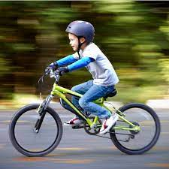 b) to go on foot
4.  c) to go by bike
5. 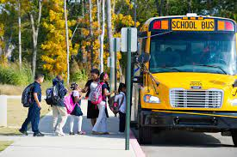 d) to go by train
6.  e) to go by taxi
7.  f) to go by bus
8. **Complete the sentences with ‘the’ where necessary:**
9. ____ Moon is very bright tonight.
10. Who is ____ president of ____France?
11. He is ____ tallest boy in the class.
12. ___ William Shakespeare wrote ____ Hamlet.
13. She is learning ___ guitar.
14. ___ kangaroo is found only in ____Australia.

**3. Fill in the sentences with ‘and’, ‘but’, ‘so’ or ‘because’:**

1. I've got a brother ____ a sister.
2. It was very sunny last Sunday, ___ we went to the beach.
3. My father likes football ____ he doesn't like basketball.
4. We aren't going to the bank ____ it is closed.
5. It is rainy today, ____ take your umbrella ___ your boots.
6. I didn't buy the new shoes ____ I didn't have any money.
7. Vigo is hotter than Santiago, ____ Santiago is more beautiful.
8. She wants to go to the cinema, ____ I don't like that film.
9. I can't sleep, ___ I'm going to drink a glass of hot milk.
10. I'm studying English ___ I love languages.

**4. Fill in the sentences with words from the box:**

|  |
| --- |
| Article, flag, language, plane, camping, to discover, “Down Under”, leaflets |

1. Some people like going ______ and watching the nature around.
2. We can learn about the place, its history and lifestyle of its people from the _______.
3. The US _____: the stars and stripes.
4. Travel agencies give ______ with their programmes of the trips.
5. People also call Australia _______.
6. If it is far away, then travelling by ______ is comfortable.
7. It is always interesting ________ new things.
8. Over 350 million people use English as their first ________.

**Reading**

1. **Complete the sentences in the text with the words from the box/ Заповніть пропуски в реченнях словами з таблички:**

|  |
| --- |
| transport, buses, country side, trains, fastest, work, place |

In Britain the most popular form of 1) ________is the car. People use it to get to 2) _____, to go to the supermarket or to take children to and from school. But in busy centres where there is no much 3) ______ for parking people use public transport such as taxis, buses and 4) ______. In London the underground is the 5) _________ way of travelling around the city. In the 6) ___ things are different. People travel by car because 7) ______and trains are not often.

**6. Use the text. Write if the sentences are true or false. /Визначте правдивість чи хибність речень на основі прочитаного тексту:**

1) People don 't use cars so often in Britain. ________

 2) Cars are the most popular form of transport in Britain. ______

3) There is a little place for leaving cars in the centre of the city. ______

4) People prefer public transport in the centre of the city.

5) Underground is a very fast way of travelling around the country. ______

6) You can't see buses and trains in the countryside very often. _____

6. Homework

1. Виконати письмово вправу подану нижче (на означений артикль the).

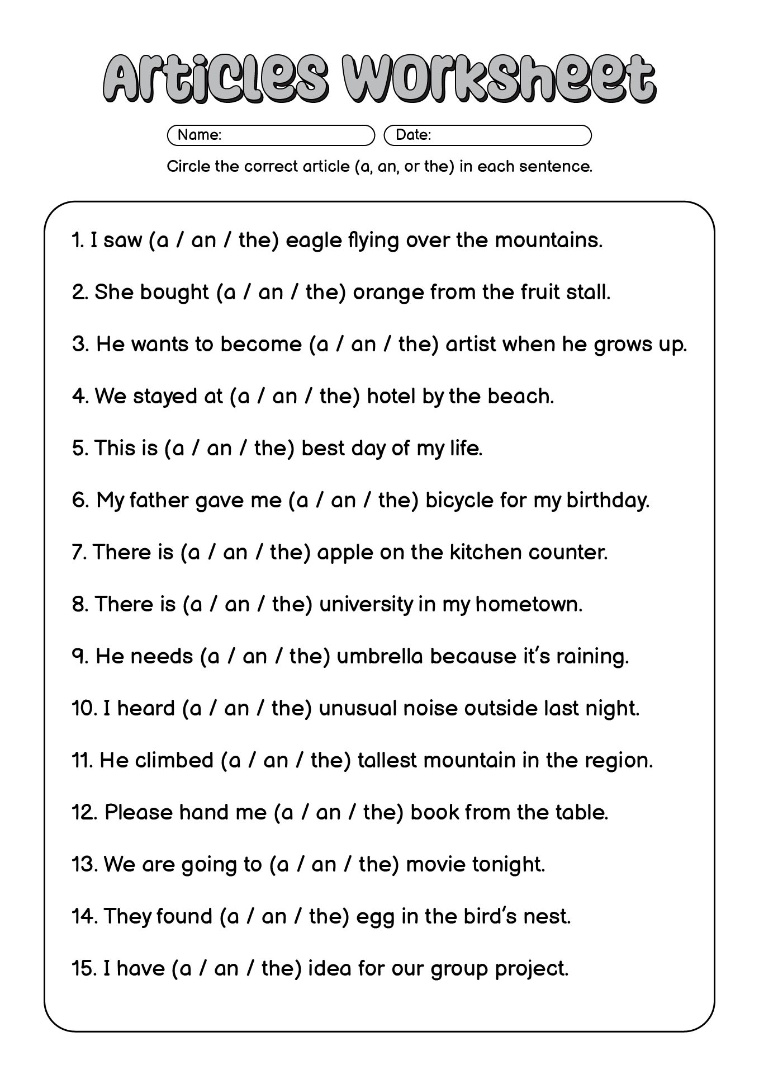

2. Повторити слова у словнику., вивчити правила щодо вживання артиклів.